Netflix Content Strategy: Insights and Recommendations
Oct 24, 2026 · @Mark

Executive summary
Netflix's catalog growth has plateaued at about 2,000 titles a year, and the mix is shifting toward international TV. Future value will come from better content choices and better metadata, not more volume.
This report analyzes 8,786 Netflix titles added up to September 2021. It combines trend analysis with three models: a forecast of future additions, a classifier that predicts a title's audience, and a content recommender.
Headline findings
- Growth has stopped accelerating. Additions peaked at 2,013 titles in 2019. The best forecasting model expects about 1,970 in 2022.
- TV is gaining share. TV rose from 25% of additions in 2018 to 34% in 2021.
- Growth markets are TV markets. Outside the US, Japan, Pakistan and South Korea grew fastest, and all three are mainly TV. India, the second-largest market, is almost all film.
- Metadata is the main constraint. 29% of titles have no director and none have plot descriptions, which limited every model.
Top recommendations: keep shifting toward series, grow international TV in fast-growing markets, and invest in metadata quality. All six recommendations are in the Business recommendations section.

Data and method
The analysis uses the Netflix titles dataset: 8,790 rows with type, title, director, country, date added, release year, rating, duration and genres. It covers titles added from January 2008 to 25 September 2021.
Stage | What was done
Cleaning | Removed 4 duplicate titles, converted 2,875 hidden "Not Given" values to missing, fixed whitespace, parsed dates, split duration into minutes and seasons, grouped 14 ratings into 5 audience groups. 8,786 titles remain.
Exploration | Trends by year, type, country, genre, audience and format.
Forecast | Six models compared in a rolling backtest (4 periods, 6 months ahead each).
Classifier | Five models compared with 5-fold cross-validation and a held-out test set.
Recommender | TF-IDF features with weighted cosine similarity, checked against random and genre-only baselines.
Dashboard | One interactive web page with filters, model results, a title search and a rating review list.
Tools: Python (pandas, scikit-learn, statsmodels, matplotlib) and Plotly.js for the dashboard.

Key findings

Growth has plateaued, and TV is gaining share
Additions grew from 426 titles in 2016 to a peak of 2,013 in 2019, then dipped 7% in 2020. Comparing January to August only, 2021 was 8% above 2020, so the catalog has settled at about 2,000 titles a year.
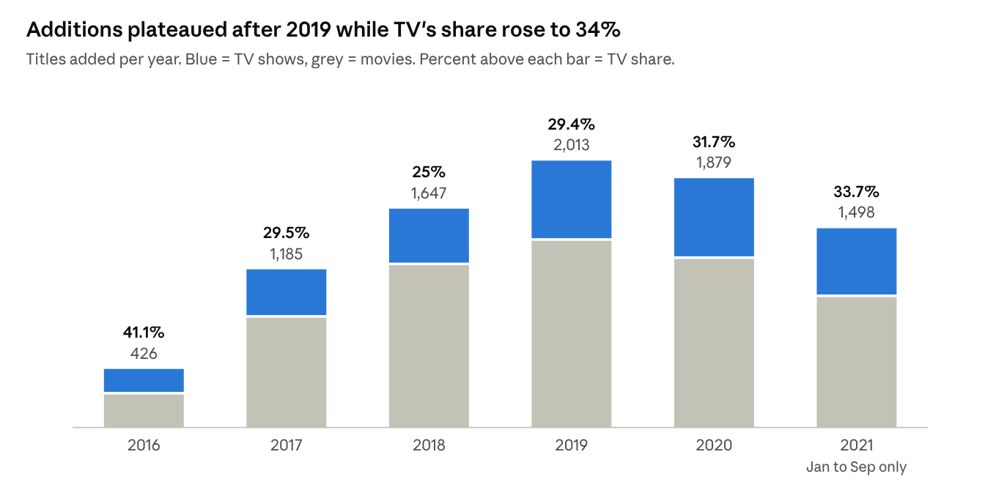
netflix_cleaned.csv · titles by year added, 2016 to Sep 2021
TV's share first fell as movie additions boomed, then rose every year after 2018. TV shows usually reach Netflix in their release year, while movies arrive a median of 2 years after release.

International TV is where growth is
The US leads, but outside it the fastest-growing markets are all TV-heavy. Growth compares titles added in 2019 to 2021 with 2016 to 2018.
Country | Titles | TV share | Growth
Japan | 259 | 66% | +104%
United States | 3,240 | 26% | +87%
Pakistan | 420 | 83% | +82%
South Korea | 214 | 77% | +68%
France | 213 | 31% | +61%
Spain | 182 | 29% | +32%
United Kingdom | 638 | 39% | +20%
Canada | 271 | 31% | +20%
Mexico | 138 | 35% | +17%
India | 1,056 | 8% | +10%
India stands out: the second-largest market by titles, but 92% film and the slowest growth of the top 10.

Audience and format
- 46% of titles are rated for adults (TV-MA, R, NC-17). Teens make up 30% and kids 23%.
- TV skews younger than film: 10% of TV shows are for little kids, against 5% of movies.
- Movies are a consistent length: median 98 minutes, mostly 87 to 114.
- 67% of TV shows have one season. The data cannot say how many are planned limited series and how many were cancelled.

Predictive models
All three models beat their baselines, and in each case the simplest approach that worked was kept.

Forecast of monthly additions
A 12-month average forecasts 164 titles a month (80% interval 125 to 222), or about 1,970 titles in 2022. It was the most accurate of six models in a rolling backtest.
Model | Average error (titles per month)
12-month average | 35.0
Seasonal naive | 36.6
ARIMA(1,1,1) | 37.0
Damped trend (ETS) | 38.0
Holt-Winters | 43.0
Linear trend | 49.0
The linear trend was worst because it projects the 2016 to 2018 boom forward. Lesson: extrapolating early growth overestimates the future.

Audience classifier
Gradient boosting predicts whether a title is for Kids, Teens or Adults with 66.4% accuracy on unseen titles, against 46% for always guessing Adults (macro F1 0.66).
- Kids and Adults are each recognized about 71% of the time. Teens is hardest (56%), because teen and adult titles share the same genres.
- Only 5% of adult titles were predicted as Kids, the most costly mistake.
- The most important features were the Children & Family Movies and Kids' TV tags, then movie length.
The obvious target, Movie vs TV Show, was rejected: every genre tag belongs to only one type, so any model scores 100% without learning anything (target leakage).

Content recommender
For any title, the recommender returns the six most similar titles by genre, director, country, type, audience and decade. On 1,000 test titles it matched the audience group 94% of the time, against 50% for a genre-only model and 32% for random picks. Its main limit is the lack of plot descriptions: it cannot tell two crime dramas apart by story.

Business recommendations
Six recommendations follow from the findings. Each rests on catalog data only, so each lists what viewing or internal data should confirm before acting.
# | Recommendation | Evidence | Validate with
1 | Keep shifting the mix toward series | TV share of additions rose from 25% (2018) to 34% (2021). Series arrive on Netflix when new; movies a median of 2 years after release. | Viewing hours and retention by type
2 | Grow international TV in fast-growing markets | Outside the US, Japan (+104%), Pakistan (+82%) and South Korea (+68%) grew fastest and are 66% to 83% TV. India is 8% TV and grew 10%. | Regional subscriber growth and viewing of local series
3 | Plan for a stable volume, not growth | Additions peaked at 2,013 (2019) and settled near 164 a month. The forecast for 2022 is about 1,970. | Content budget and licensing pipeline
4 | Invest in metadata quality | 29% of titles lack a director, 53 carry only the generic genre "Movies", and there are no plot descriptions. These gaps limited every model. | Search and recommendation click-through before and after
5 | Use the classifier as a rating review aid | It flags 48 of 8,704 rated titles where the rating and the metadata disagree sharply, a list small enough to check by hand. | A sample review of flagged titles
6 | Track why most series stop at one season | 67% of TV shows have one season. The data cannot separate limited series from cancellations. | Internal renewal records
On the rating review list: most flagged titles are probably rated correctly. They fall into three patterns: clean stand-up comedians rated TV-PG, older PG films with horror themes (from before PG-13 existed), and short specials tagged only "Movies". The last pattern is a metadata problem, which supports recommendation 4.

Limitations and next steps
The biggest limit is that this is catalog data: it shows what Netflix offers, not what people watch.
- No viewing or subscriber data, so no finding measures success or demand.
- A snapshot to 25 September 2021. 2021 is partial, and titles removed before then are missing.
- One country per title, so co-productions count only for the listed country.
- 29% of directors missing and no plot descriptions, which cap the recommender and classifier.
- Short history for forecasting: about 5.5 years of monthly data, including a boom and a plateau.
Next steps: add viewing data to test each recommendation, add plot descriptions to the recommender and classifier, and re-run the forecast as new months of data arrive.

Appendix: deliverables
File | What it is
Task6_Business_Insights_Dashboard.ipynb | Runs the full analysis and models, then builds the dashboard
dashboard.html | The interactive dashboard: one web page, opens in any browser
dashboard_template.html | The dashboard's layout and code, filled with data by the notebook
netflix_cleaned.csv | The cleaned dataset from Task 1
Using the dashboard
- Open dashboard.html in a browser (an internet connection is needed to load the charting library).
- Use the Type, Added from/to and Country filters; the KPI tiles and overview charts update instantly.
- Type any title in Find similar titles to see its six closest matches and the genres they share.
- Filter the Rating review list by flag type to see why titles were flagged.
- To share it online, upload it to a GitHub repository and turn on GitHub Pages.
Detailed work for each model is in Tasks 1 to 5: cleaning, exploration, recommender, forecast and classifier.

